Chemaster Use Cases
User Requirements

Document Information
Title | Chemaster Use Cases  User Requirements
Description | Definition of the use cases of Chemaster
Intended Audience | Developers
Author | Pantelis Sopasakis
Date | 13.05.2012

Database Serialization from SD Files

Chemaster Use Case 1
Title | DB Serialization from SDF.
Goal | User needs to populate the database with more molecules that will be possibly used for virtual screening.
Input | SD File – possibly generated by Marvin Sketch.  It is advisable that the SD file contains also the IUPAC names for each compound.
Output | Molecules are stored in the database in various formats among which smiles, sdf and InChi. Molecules are identified by their InChiKey hash and molecules with equal InChi keys are considered to be the same.
Further Specifications | No duplicated are allowed in the database.
Extensions | - The IUPAC Name is retrieved from PubChem and is stored along with the compound in case it was not provided by the end user.  - Upon registration, some basic descriptors are also generated and stored.
Exceptional Events | If conversion from the given data into any of the alternative file formats fails then a warning message is returned but registration does not stop; it continues for all other representations. (e.g. if it fails for smiles it does not mean it will fail for xyz).  In case a chemical compound is provided for which no name can be found the the user is asked to provide one manually. This should mean that no identifiers where provided in the SDF file and that the given chemical was not found in the database.
Java Code | MolWriter my_writer = new MolWriter("mols.sdf");  my_writer.write();
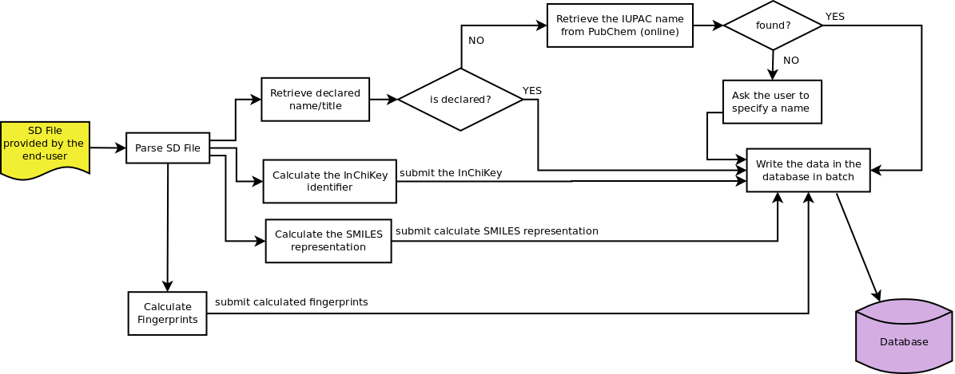
Data registration from an XLS file

Chemaster Use Case 2
Title | Data registration from an XLS file.
Goal | Users should be able to register data using just an XLS file whose first column is the InChiKey and the rest refer to properties and their units and conditions. The user stores also bibliographic information regarding where the value was retrieved from.
Input | XLS File formatted by the user.  An example file “experimental_data.xls” is given to the end-user as a prototype.
Output | Properties of molecules are stored in the database.
Further Specifications
Extensions
Exceptional Events | The XLS file should be well formed according to the specifications.

Import of Dragon Descriptors

Chemaster Use Case 3
Title | Import of Dragon Descriptor Values.
Goal | The user has calculated descriptors using Dragon 6.0 and needs to store these values in the database.
Input | - Output file from Dragon in TSV format (Tab Seper. Values)  - Initial SDF file used as input to Dragon
Output | Properties of molecules are stored in the database.
Further Specifications
Exceptional Events | - One of the two files does not exist  - Files have different number of rows  - Entries are inconsistent
Java | PopulateDescriptors pd = new PopulateDescriptors("mol.sdf", "dsc.txt");  pd.write();

